Asia-China-Coin-3-Round-3-Round-FD 390 R3

SHAPE \* MERGEFORMAT 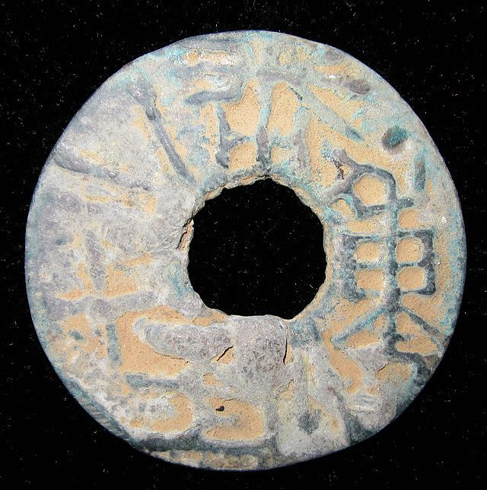

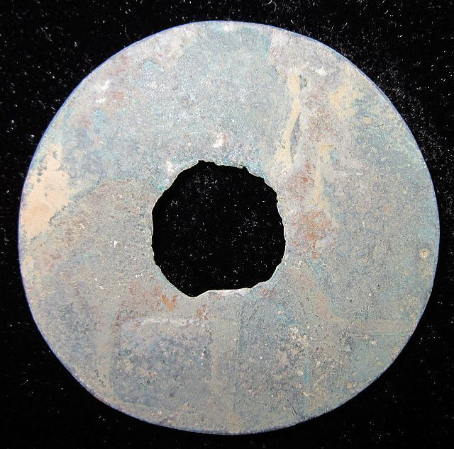

Order details Printer friendly page

Sold by

[cnrelics](http://myworld.ebay.com/cnrelics) ( [18](http://feedback.ebay.com/ws/eBayISAPI.dll?ViewFeedback&userid=cnrelics)  )

+ Show additional actions

Delivery package 1 of 1

Estimated delivery Tuesday, Jan 28, 2014 - Thursday, Feb 13, 2014

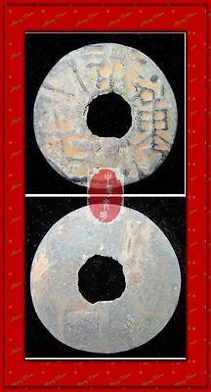

[WARRING STATES PERIOD QIN NATION WEIGHT 12YEAR NUMBER MONEY BRONZE COIN重一两十二珠1"](http://www.ebay.com/itm/151197385445)

Item price

$69.99

Quantity

1

Item number

151197385445

Shipping service

Economy Shipping from outside US

[Leave feedback](http://feedback.ebay.com/ws/eBayISAPI.dll?LeaveFeedbackShow&useridfrom=802-867&useridto=cnrelics&item=151197385445&transactid=0) [Contact seller](http://contact.ebay.com/ws/eBayISAPI.dll?FindAnswers&frm=3998&iid=151197385445&redirect=0&requested=cnrelics) [Return item](http://return.ebay.com/ws/eBayISAPI.dll?ResolveReturn&eventName=viewSelectedItem&TransactionId=0&ItemId=151197385445)

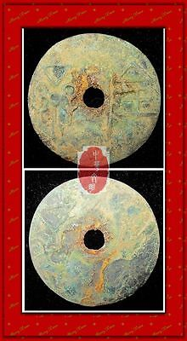

[WarringStatesPeriod WEI NATION WAR CITY MINT MONEY BRONZE ROUND COIN济阴圜钱1.5"RARE](http://www.ebay.com/itm/151198705295)

Item price

$49.99

Quantity

1

Item number

151198705295

Shipping service

Economy Shipping from outside US

[Leave feedback](http://feedback.ebay.com/ws/eBayISAPI.dll?LeaveFeedbackShow&useridfrom=802-867&useridto=cnrelics&item=151198705295&transactid=0) [Contact seller](http://contact.ebay.com/ws/eBayISAPI.dll?FindAnswers&frm=3998&iid=151198705295&redirect=0&requested=cnrelics) [Return item](http://return.ebay.com/ws/eBayISAPI.dll?ResolveReturn&eventName=viewSelectedItem&TransactionId=0&ItemId=151198705295)

### Shipping address

Ralph J Coffman Jr  
149 Atlantic Ave   
Swampscott MA 01907-2427  
United States

Phone number  
781 584 7091

### Order total

Subtotal $119.98

Shipping $20.00

Discount -$2.00

#### Total

## $137.98

[View PayPal transaction](http://payments.ebay.com/ws1/eBayISAPI.dll?IntermediateResolutionInfo&itemid=0&transId=0&pn=UnifiedCheckoutSummaryRedirect2PP&qs=itemid%3D0%26transId%3D0%26buyerorseller%3D0%26)

### Order information

Order placed on  
Tuesday, Jan 7, 2014

Having a problem with this purchase?  
[Resolve problem](http://res.ebay.com/ws/eBayISAPI.dll?ResolutionCenter)

Payment method   
PayPal

Payment date  
Tuesday, Jan 7, 2014

# WARRING STATES PERIOD QIN NATION WEIGHT 12YEAR NUMBER MONEY BRONZE COIN重一两十二珠1"

### Seller information

|  |  |
| --- | --- |
|  |  |

[cnrelics](http://myworld.ebay.com/cnrelics?_trksid=p2047675.l2559) ([18](http://feedback.ebay.com/ws/eBayISAPI.dll?ViewFeedback&userid=cnrelics&iid=151197385445&ssPageName=VIP:feedback&ftab=FeedbackAsSeller&rt=nc&_trksid=p2047675.l2560) )

100% Positive feedback

[Follow this seller](http://www.ebay.com/itm/WARRING-STATES-PERIOD-QIN-NATION-WEIGHT-12YEAR-NUMBER-MONEY-BRONZE-COIN-1-/151197385445?_trksid=p2047675.l2557&ssPageName=STRK%3AMEWNX%3AIT&nma=true&si=5L4Tlo08dyY9pQflhUEb6fWvMTI%253D&orig_cvip=true&rt=nc)

[See other items](http://www.ebay.com/sch/cnrelics/m.html?item=151197385445&nma=true&rt=nc&si=5L4Tlo08dyY9pQflhUEb6fWvMTI%253D&orig_cvip=true&ssPageName=STRK%3AMEWNX%3AIT&_trksid=p2047675.l2562)

Top of Form

## Item Information

Item condition:

--not specified

“Rust on the body,Museum quality”

Ended:

Jan 02, 2014 18:01:36 PST

Winning bid:

US $69.99

[ [1 bid](http://offer.ebay.com/ws/eBayISAPI.dll?ViewBids&_trksid=p2047675.l2565&rt=nc&item=151197385445) ]

[Add to list](http://cgi1.ebay.com/ws/eBayISAPI.dll?MakeTrack&_trksid=p2047675.l1360&rt=nc&item=151197385445&sourcePage=4340&ssPageName=VIP:watchlink:top:en&SubmitAction.AddToListVI=x&wt=500349f4256bdc789100e998987dfa4d)

|  |  |  |  |
| --- | --- | --- | --- |
|  | Join **eBay Bucks** and earn **%** back on this item. [See conditionsfor eBay Bucks - opens in a new window or tab](http://pages.ebay.com/rewards/terms.html?ssPageName=STRK:VI:LNLK:TCS) | | |
|  | | New customers get $10 back on 1st purchase Subject to credit approval.[See terms](https://apply.billmelater.com/apply?guid=F2W40R2E&assetId=NBRVI0114) |  |

Shipping:

$10.00 Economy Shipping from outside US | [See details](http://www.ebay.com/itm/WARRING-STATES-PERIOD-QIN-NATION-WEIGHT-12YEAR-NUMBER-MONEY-BRONZE-COIN-1-/151197385445?_trksid=p2047675.l2557&ssPageName=STRK%3AMEWNX%3AIT&nma=true&si=5L4Tlo08dyY9pQflhUEb6fWvMTI%253D&orig_cvip=true&rt=nc" \l "shpCntId)

See details about international shipping here.

Item location:

BeiJing, China

Ships to:

Worldwide

Delivery:

Estimated within 14-33 business days

Please note the delivery estimate is greater than 13 business day

Bottom of Form